Freesurfer Norm Scores Protocol

Kayti Keith - 6/21/19 Last Updated: 11/6/19

* Cortical segmentation via Freesurfer recon-all:
  + `recon-all -all -i [path to T1] -sd [study directory containing T1s] -subjid [subject ID]`
  + **Note:** Freesurfer takes a ***very*** long time to process one subject (15-20 hours depending on the system). Because of this, it may be necessary to run several instances of Freesurfer at once. This speed up the process *mildly*.
    - One tactic is to start several for loops that will run simultaneously

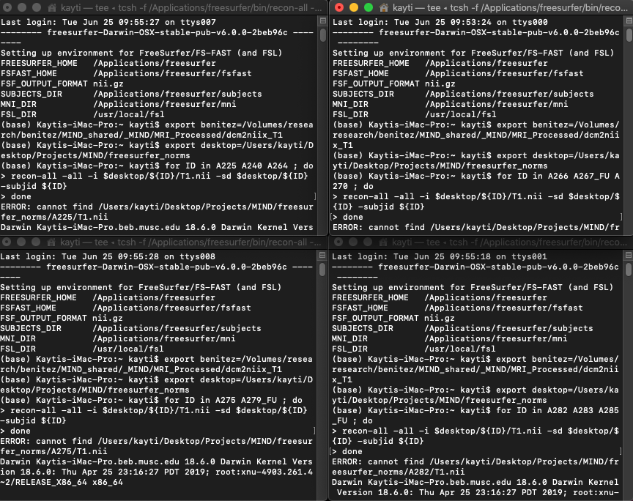

* + - Notice that each of these windows contains a *for loop* with select subjects from the larger group
      * Ex:
      * `for ID in Subj1 Subj2 Subj3 ; do

recon-all -all -i $T1_Folder/${ID}/T1.nii -sd $desktop/${ID} -subjid ${ID}

done`

* + - Due to the lengthy processing time of recon-all, it helps to be prepared to deal with stopped scripts due to computer errors, power outages, etc.
      * When recon-all is complete, it will generate a file in the main subject folder called “fslaverage”
      * 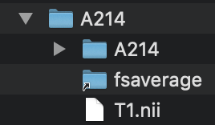
      * If your script stops, look for this file. If this file is present, you know that recon-all is complete for that subject. You can remove that subject from your script and continue processing other subjects.
  + **Note 2**: It is possible that your computer will stop or slow processes when it is asleep. It may be necessary, for the duration of your Freesurfer processing, to not allow your computer to go to sleep (but rather simply lock the display)
    - To turn off sleep on a Mac: Click the Apple > System Preferences > Energy Saver > check “Prevent computer from sleep automatically when display is off”
* QC registration 5% lowest and highest eTIV in Freeview
  + QC thresholds:
    - Inadequate inclusion
    - Omission of 100 or more voxels
* Arrange files in correct format for Norm Score app
  + The Norm Score app (NormsCalculator.app) will require access to Freesurfer outputs and a specifically formatted .csv sheet
    - File structure for outputs:
      * 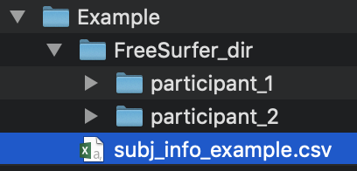
    - .csv sheet format:
      * 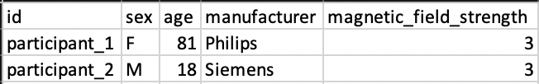
      * **Note**: Make sure the .csv sheet you give the app is in this exact format.
        + Sex should read only “F” or “M” exactly
        + Age should be only two digits with no decimal points (hidden or otherwise)
        + All fields should be formatted as “General”
        + 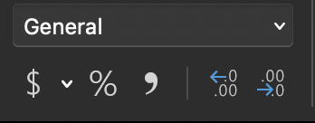
* Open NormCalculator.app
  + 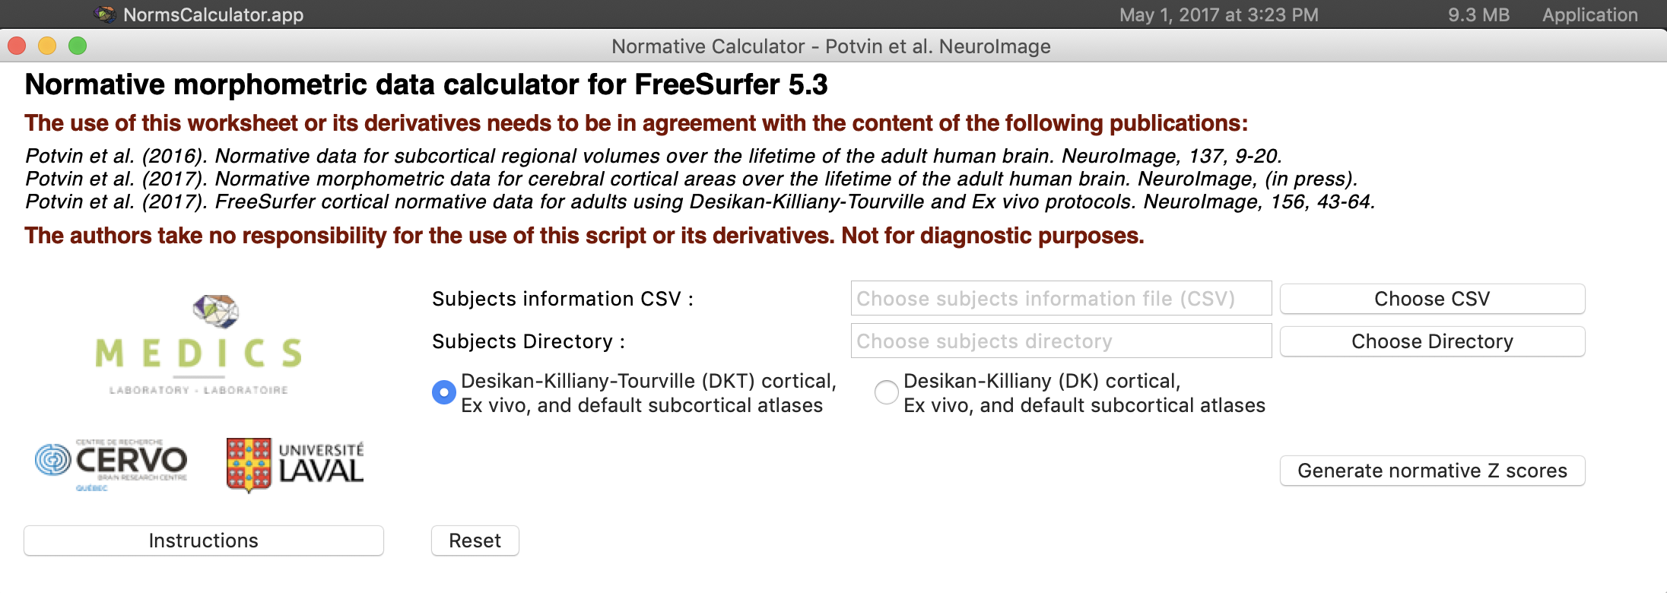
  + Subjects information CSV = preprepared .csv file
  + Subjects Directory = directory where all of your Freesurfer outputs are stored